Class B,Beginners.
Easter customs and traditions
- Look at the photo and read the text below about Easter.

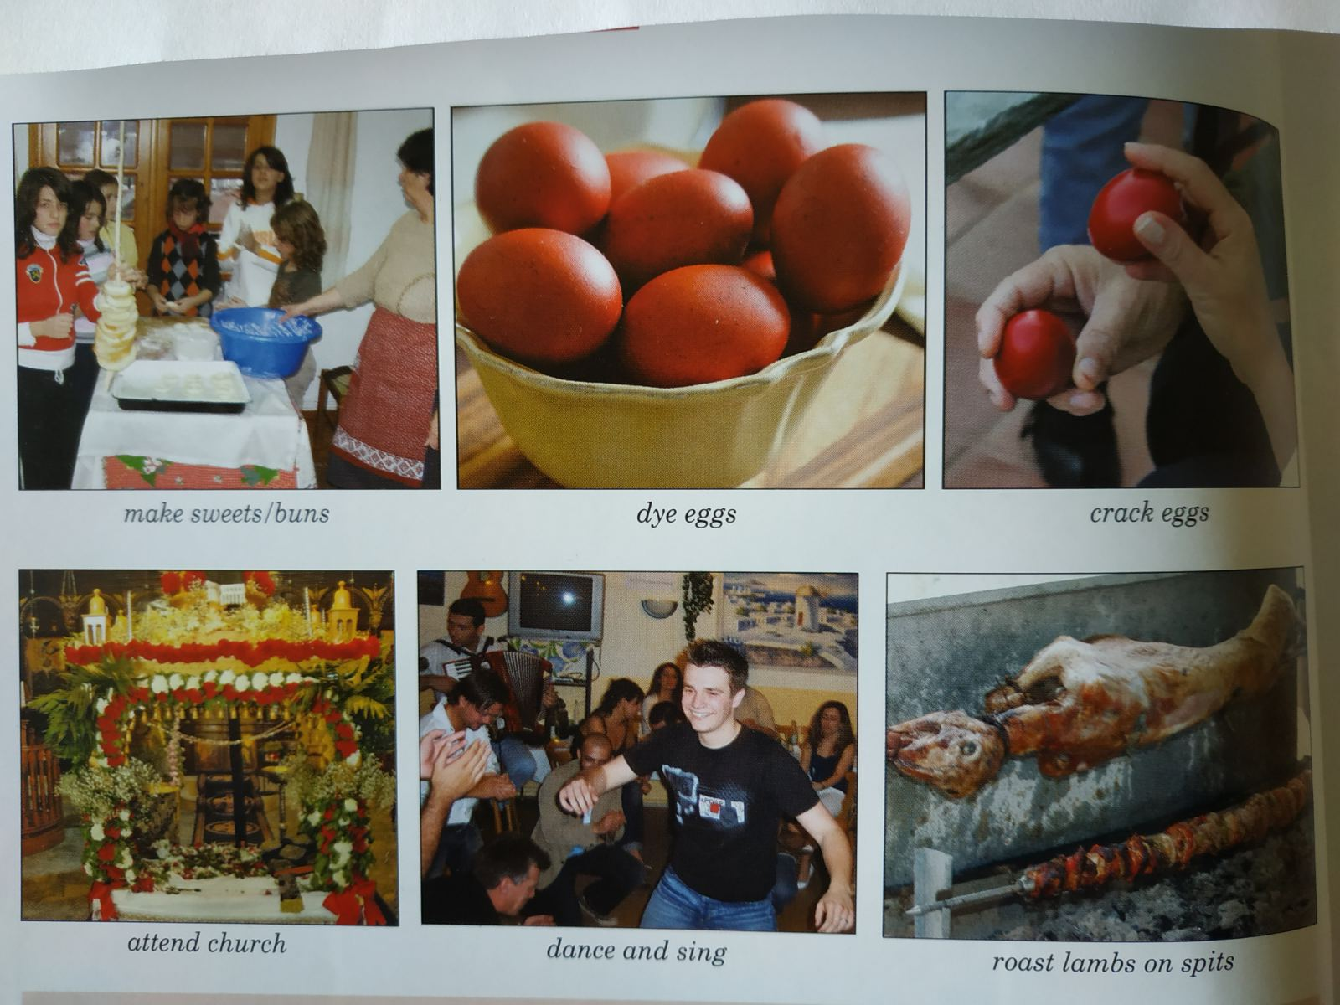
Now think: How is Easter celebrated in Greece?
You don’t have to send me your answer. It’s only for speaking practice
